Lab Task 07

Task01: Define three arrays arr1[], that take input numbers from the user and arrodd[] that will take store odd number and arreven[] that will store event numbers

Write a program that separates and copies the odd and even elements given by the user to the arrays arrodd[] and arreven[]

Task02: Rolling a Die 100 times and Summarizing the results in an Array

Modify the blow given program so that it can display results in Histogram format as shown blow:

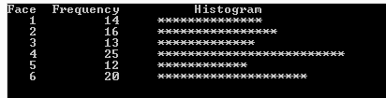

Task03: Complete the code of following function so that output should be like given output: you are not allowed to change the main function, see the comments in function to complete it

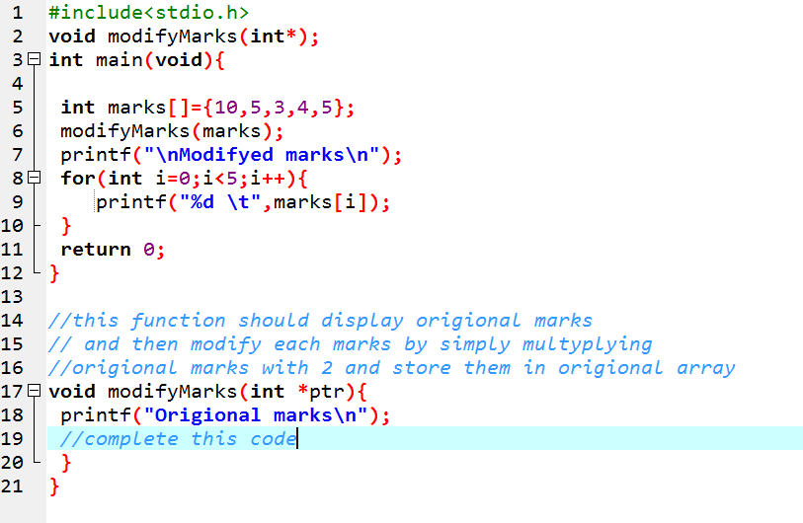

Output should be like this: Remember you have to compile and show your output don’t copy my output

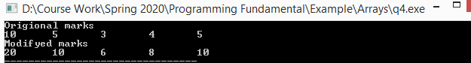

Lab Task 04: Write a program that store 3 students grades (4 test marks for each student).

Print these marks

Display Average of each student

Calculate minimum and ma ximum marks using a single function

* For example store marks as follows

int studentGrades[ 3 ][ 4 ] = { { 77, 68, 86, 73 }, { 96, 87, 89, 78 }, { 70, 90, 86, 81 } };

The output should be like this:

